Network Assingmnet 2

CAPTAIN JAMAL AHMED

10/8/2012

BESE-16B

JAMAL-PC

**SUBMITTED TO :**

**Lt Col Ishtiaq (sigs)**

ASSIGNMENT # 2

Due Date 8 Oct 2012 In hard copy (Typed or hand writen)

**Question No 1.**

**Differentiate and explain with the help of an example type of addresses (Physical, Logical, Port and Specific addresses)?**

**ANSWER :-**

**1. Logical Address (IP Address)**

***A Logical address is a 32- bit address assigned to each system in a network. This works in Layer-3 of OSI Model. This would be generally the IP address.***

An IP address of the system is called logical address. This address is the combination of **Net ID and Host ID**. This address is used by network layer to identify a particular network (source to destination) among the networks. This address can be changed by changing the host position on the network. So it is called logical address.

**Why Logical Address was Required ??**

In an internet work environment where different networks are involved which uses different formats for physical addressing; **a universal addressing system is needed in which each host can be identified uniquely.** The logical addresses are designed for this purpose. Logical addresses are necessary for universal communication that is independent of underlying physical networks. Duties of a physical address are limited to the LAN they are operating in. The logical address in the internet is currently a 32 bit address. No two visible hosts can have the same IP address.

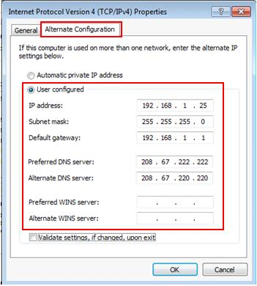**Example :-**

|  |
| --- |
| 1. It can be changed as you like used for assigning a ip address to clients. 2. A physical address is a 32-bit flat address. 3. Logical address is used in virtual memory. |

|  |
| --- |
|  |
| **2. Physical Adress (MAC Adress)**  ***A Physical address is a 48-bit flat address burned into the ROM of the NIC card which is a Layer1 device of the OSI model***.  Every piece of equipment that connects to a network, whether an office network or the Internet, has a physical address. This is an address that's unique to the piece of equipment that's actually attached to the network cable. **This is divided into 24-bit vendor code and 24-bit serial address. This is unique for each system and cannot be changed**. In computing, a physical address, also real address, or binary address, is the memory address that is represented in the form of a binary number on the address bus circuitry in order to enable the data bus to access a particular storage cell of main memory.  It is the address of a node as defined by its LAN or WAN. It is included in the frame used by the data link layer. It is the lowest level address. **In computer networking, physical address is sometimes a synonym of MAC address**. The address is actually used on the network's data link layer, not on the physical layer, as the name would suggest.  Each system having a NIC(Network Interface Card) through which two systems physically connected with each other with cables. The address of the NIC is called Physical address or Mac address. This is specified by the manufacture company of the card. **This address is used by data link layer**.  a. Frames need to be transmitted to different systems on a network.  b. Data link layer adds a HEADER to frame.  c. Header defines the physical address of sender (Source address) and receiver address (Destination address).  d. Frame is intended for a device outside the network.  **Example**   * Click on Start and Choose Run. * Type cmd into the text box. * At the prompt type ipconfig /all and hit Enter. (Note: there is a space between ip config and the forward slash.) * Locate your ethernet adapter description. Under description, you will see the category labled Physical Address. The the righ is your MAC address. Example: 00-1F-3B-99-34-7D   **Example 2**  Consider the example of the ring topology shown above. Adjacent to the nodes (computers) I have placed the imaginary physical addresses of each node.http://help.unc.edu/ccm/groups/public/@km/@its_resnet/documents/kbarticles/~export/CCM3_007643~1~DC_GUI_TEMPLATE_HELP~DC_SNIPPET/9282-3.jpg Data link layer of the node with physical address 40 receives the data from the upper layer and encapsulates the data in a frame, adding a header and a trailer. This node (sender) then sends this frame to a node with physical address 20 (receiver). Each station with physical addresses other than 20 rejects it and it moves on until it reaches the correct destination with physical address 20.  **3. Port Address**  ***Port Addresses Are Used For Process Communicating With Another Process***  There are many application running on the computer. Each application run with a port no(logically) on the computer. This port no. for application is decided by the Kernal of the OS. This port no. is called port address. In Transport layer. Today’s computers are devices that can run multiple processes at the same time. For example if a computer is communicating with two other computers at the same time, for these processes to receive data simultaneously, we need a method to label different processes. This is where port addressing comes in to play. In TCP/IP architecture, the label assigned to a process is called port address (16 bit).   1. It allows a single IP address to be used for many internal hosts. 2. Port address can automatically modify the IP packets' destination or source host IP and port fields belonging to its internal hosts.   **Example**   |  | | --- | | http://4.bp.blogspot.com/_Ii1ukGkfijY/Sl8E1M5GJVI/AAAAAAAAAf4/WTjj-tkCYKg/s400/Network+Model7.jpg | |
|  |

The sending computer on the left is running three processes at this time with port addresses ‘a’, ‘b’, and ‘c’. The receiving computer on the right is running two processes at this time with port addresses ‘j’ and ‘k’. Process ‘a’ in the sending computer needs to communicate with process in the receiving computer (Note that although both computers are using the same application, FTP).

**4. Specific Addreses**

***Some applications have user-friendly addresses that are designed for that specific address.***

These addresses get changed to the corresponding port and logical addresses by the sending computer.

**Example :-**

1. The e-mail address (for example, network-model@network.edu) and the Universal Resource Locator (URL) (for example, [www.youtube.com](http://www.youtube.com)).
2. The first defines the recipient of an e-mail; the second is used to find a document on the World Wide Web.
3. [www.facebook.com](http://www.facebook.com) etc

**Question No 2.**

**Briefly describe the responsibilities of each OSI Model Layers?**

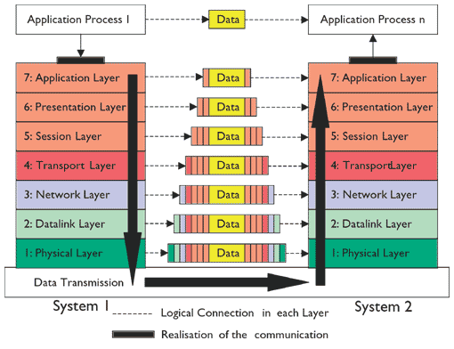

**1. The physical layer** It is responsible for transmitting a bit stream over a physical medium. It is concerned with

a. Physical characteristics of the media.

b. Representation of bits.

c. Type of encoding.

d. Synchronization of bits.

e. Transmission rate and mode.

f. The Way devices are connected with each other and to the links.

**2. Data Link Layer:** It is responsible for moving frames from one node to another.

1. It divides the stream of bits received from the network layer in to manageable data units called frames.
2. PDU: Frames.
3. Keeps Link alive & provides connection for upper layer protocols.
4. Based on physical (flat) address space.
5. Physical addresses are fixed and don’t change when the node is moved.
6. Medium/media access control.
7. Flow control and error detection/correction at the frame level.

h. Ex: Ethernet, Token Ring, ISDN.

i. Devices: switches, bridges, NIC’s.

**3.** **Network Layer** is responsible for routing, directing datagrams from one network to another.

* 1. Translates logical network address and names to their physical address (e.g. MAC address).
  2. Responsible for addressing, determining routes for sending and managing network problems such as packet switching, data congestion and routing.

c. The network layer is a complex layer that provides connectivity and path selection between two host systems that may be located on geographically separated networks.

d. Hides the lower layers making things hardware independent.

e. Uses logical hierarchical addresses.

f. Devices: routers, firewalls.

**4.** **Transport Layer** The transport layer segments data from the sending host's system and reassembles the data into a data stream on the receiving host's system

a. Dividing the message into manageable segments.

b. Reassembling it at the destination..

c. Flow and error control.

d. Process-Level Addressing.

e. Layer 4 also deals with Flow Control, and Reliability of Communication.

f. Examples: TCP, UDP.

**5.** **Session Layer** The session protocol defines the format of the data sent over the connections. The NFS uses the Remote Procedure Call (RPC) for its session protocol. RPC may be built on either TCP or UDP. Login sessions use TCP whereas NFS and broadcast use UDP.

a. Session Establishment.

b. Sometimes called the dialog controller, this layer establishes, maintains, and terminates sessions between applications.

c. Defines checkpoints for acknowledgements during sessions between applications.

e. If you want to remember Layer 5 in as few words as possible, think of dialogues and conversations.

**6.** **Presentation Layer** The presentation layer ensures that the information that the application layer of one system sends out is readable by the application layer of another system.

**a**. Data formatting, translation, encryption, and compression.

**b**. If necessary, the presentation layer translates between multiple data formats by using a common format.

**c**. If you want to think of Layer 6 in as few words as possible, think of a common data format.

**d**. Example: ASCII, HTML, JPEG

**7**. **Application Layer** It Provides communication services to applications.

1. Used for applications specifically written to run over the network.
2. Allows access to network services that support applications.
3. Directly represents the services that directly support user applications.

d. It differs from the other layers in that it does not provide services to any other OSI layer, but rather, only to applications outside the OSI model.

e. Examples of such applications are spreadsheet programs, word processing programs, and bank terminal programs.

f. If you want to remember Layer 7 in as few words as possible, think of browsers.

g. Example: HTTP, FTP, SMTP.

**Question No. 3**

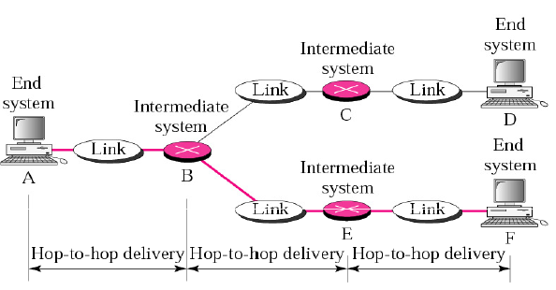**Explain with the help of diagram Hop by Hop delivery (Data link Layer), Packet by packet source to destination delivery (Network Layer), process by process source to destination delivery (Transport Layer)?.**

**1. Hop by Hop delivery: Datalink layer:** Hop-to-hop delivery means delivery of packets from the host's network interface card (NIC) to the router's interface. In hop-to-hop delivery, physical addresses of the devices are used to identify devices. The format of a physical address depends on the network type.

2. **Packet-by-Packet source-destination delivery: Network layer.** This layer is responsible primarily with routing of packets from the layer above (Transport Layer) to a remote location that may or may not share the same Physical Layer-direct-link, or even Data Link Layer.  
Packets also contain addressing information. The receiver's address needs to be attached to the packet and the sender's address is also typically required to be present. The addresses in the packets don’t have to be related to any data link address in any direct way.

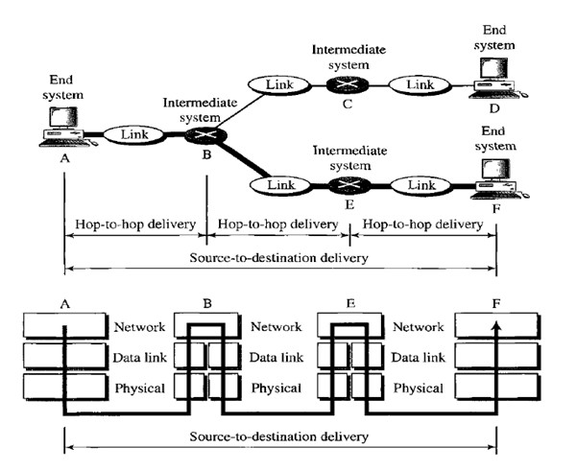

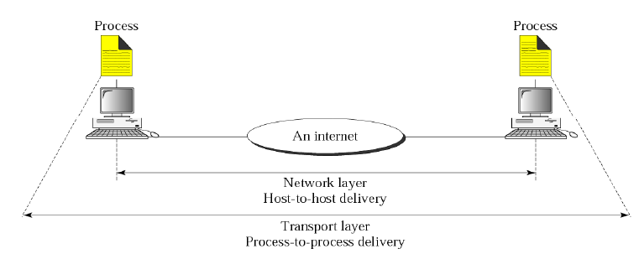**3. Process-process delivery: Transport layer:** The transport layer in a network model is responsible for process-to-process delivery of the entire message, provides end-to-end communication services for applications. A process is an application program running on a host. It treats each one independently, as though each piece belonged to a separate message. The transport layer ensures that the whole message arrives intact and in order, overseeing both error control and flow control at the source-to-destination level.

**Question No 4. Differentiate following with the help of examples in your own words:-**

**Answer:**

**1. Analog and Digital Data:** Data can be analog or digital. The term analog data refers to information that is continuous and takes continuous values, for example sound of human voice, an analog clock that has hour, minute and second hands gives information in a continuous form. Digital data refers to information that has discrete states. It takes on discrete values. For example, a digital clock that reports the hours and the minutes will change suddenly from 8:05 to 8:06.

**i. Analog Data** Analog data is real world stuff like sounds, electrical currents, paintings, temperatures, time. It has no precisely measurable or discrete value.

**ii. Digital Data** Digital data, on the other hand is discrete, consider the bitmap as compared to an original image for example, a bitmap is made up of discrete pixels in one colour or another.

**2. Analog and Digital Signals:**

**i. Analog Signals**: These signals vary with time, and the variations follow that of the non-electric signal. These signals can have infinite number of values in a range.

**ii**. **Digital signals:** Digital signals change in individual steps and consist of pulses or digits.These signals can have only a limited number of values in a range. Digital signals have discrete levels, and the specified value of the pulse remains constant until the change in the next digit. There are two amplitude levels, which are called nodes that are based on 1 or 0, true or false, and high or low.



3. **Periodic and APeriodic signals**

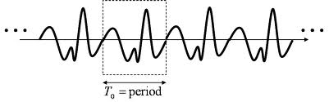**i. Periodic signal** Periodic signal completes a pattern in definite time frame called a period or we can say that a periodic signal repeats itself after equal intervals of time. The completion of a pattern is a “cycle”.

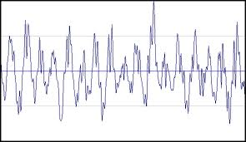**ii. Non-periodic (APeriodic).** Non-periodic or aperiodic signal does not repeat itself after equal intervals of time. It changes without exhibiting a pattern or cycle that repeats over time.

In data communications, we commonly use periodic analog signals (because they need less bandwidth)

**4. Period and Frequency** Period is the time (seconds) required for a signal to complete one cycle (T=1/f). Frequency is the number of periods in one second (f=1/T).

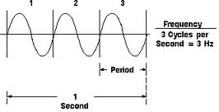

Attenuation:

**5. Attenuation, Noise and Distortion and Type of Noises**:

i. **Attenuation** It means a loss of energy. When a signal travels through a medium, it loses some of its energy in overcoming the resistance of the medium.

ii. **Distortion:** Distortion means that the signal changes its form or shape.It occurs in composite signal made of different frequencies.

iii. **Noise** Noise is undesirable variation in a signal. Figure below illustrates the effects of noise on a signal. Noise reduces the accuracy and repeatability of measurements and introduces distortion in signals. It creates errors in control systems.

a. **Thermal noise:** Due to random motion of electrons in the wire.

b. **Induced noise:** It comes from sources like motors, appliances.

c. **Crosstalk :** It is the effect of one wire on the other.

d. **Impulse noise:** It is a spike (a signal with high energy in a very short time) that comes from power lines, lightning, and so on.

**Question No 5.**

**Draw and explain how a square wave can be constructed from sine wave**.

**Answer**

***A perfect square wave can be achieved by adding odd harmonics (ideally till infinity) .***

The sine waves added in addition to the fundamental frequency are called *harmonics*; a square wave has harmonics at odd multiples of the fundamental frequency. As higher harmonics are added, the result gets closer to an ideal square wave, which contains infinite harmonics. If harmonics are reduced then a perfect square wave cannot be achieved.

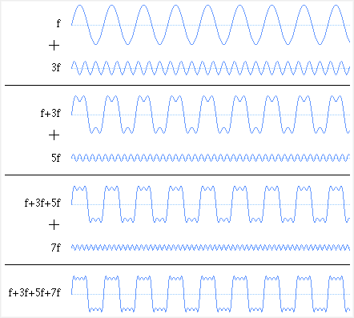

**Observation**

**As we increase the number of odd harmonics, more accurate square wave can be formed.**

**Question No 6.**

**Explain bandwidth for digital and analog Signals?**

**Answer:-**

Bandwidth describes the amount of data that can be sent through a data-transmitting medium, such as a computer network, telephone line, or coaxial cable in a given amount of time. All transmitted signals whether analog or digital have a certain bandwidth, as do receiving systems. Bandwidth is directly proportional to the amount of data transmitted or received per unit of time.

**a. Bandwidth for Digital signals:** In digital the bandwidth is **nothing but the bit rate  possible through the channel** . For digital signals, the bandwidth is the data speed or rate, measured in bits per second (bps). For example, a [modem](http://encyclopedia2.thefreedictionary.com/modem) with a bandwidth of 56 kilobits per second (Kbps) can transmit a maximum of about 56,000 bits of digital data in one second. Digital signals require more bandwidth.

b. **Bandwidth for Analog signals: *For analog signals, it is the difference between the highest and lowest frequency components, measured in hertz (cycles per second).***

For example the human voice, which produces analog sound waves, has a typical bandwidth of three kilohertz between the highest and lowest frequency sounds it can generate. Analog signals require less bandwidth.

**Question No 7**



**Answer:**

a. 90 degrees (π/2 radian)

b. 0 degrees (0 radian)

c. 90 degrees (π/2 radian)

**Question No 8**

**HDB3 will be used**

**e-g**

Following 20 Bits are to be transferred. 11000010000000010000

Then Following pattern will be used.

